2 Bridge

Contents

What is the Bridge Tool? 1

How to Turn on Loop Tools 2

Joining Two Objects Together 3

How do you use the Bridge Tool? 4

The Options for the Bridge Tool 5

Cutting a Hole 7

# What is the Bridge Tool?

The Bridge Tool is the first gadget that you will come to, when you open the Loop Tools.

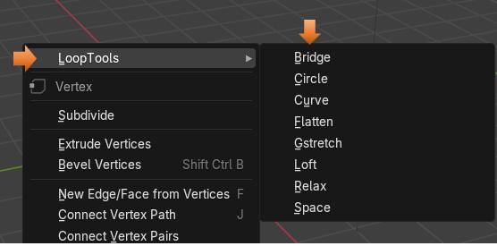

This Tool is used to connect multiple edge loops or face groups. It can also be used to cut a hole in your 3D models.

Of course, as we had explained in our Last tutorial on Introduction to Loop Tools, we first need to turn the set of Loop Tools on in Blender before we can use them. So, next I will provide an overview of that very important initial step.

# How to Turn on Loop Tools

You will want to go to:

Edit-Preferences- Add-ons then just enable Loop Tools.

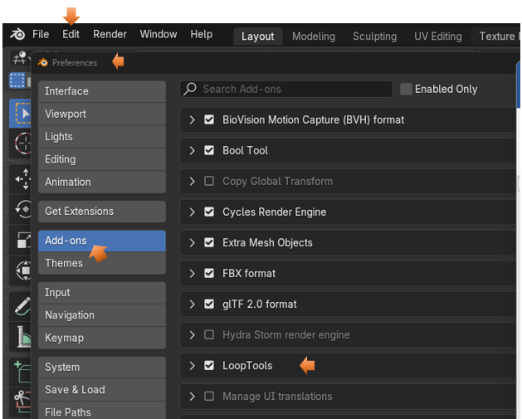

# Joining Two Objects Together

If you are following along from our last article, on the Introduction to these tools; you will remember that if we bring in two separate objects, in Object mode, that they will first need to be joined together before we can bring them into Edit mode and use our loop tools on them.

So, let’s start off with those two cylinders that we used as an example in our previous tutorial.

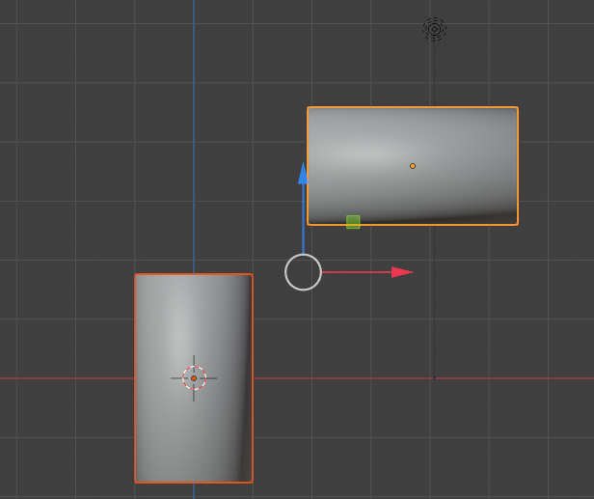

Now select these two cylinders and hit ctrl-J to join them together. Remember once they are joined that both of our outlines around both of them will be orange.

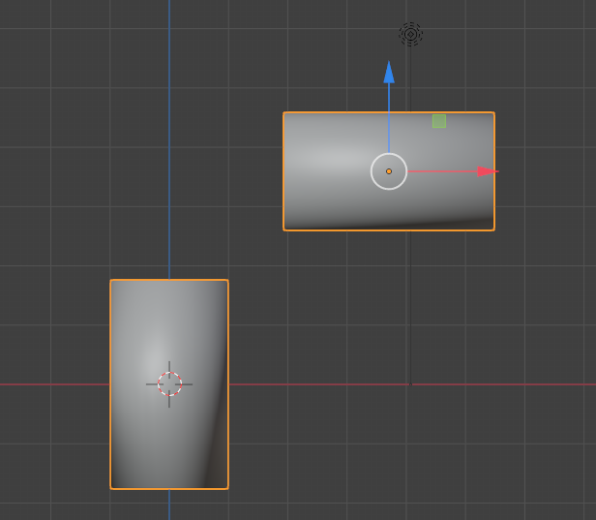

# How do you use the Bridge Tool?

Once in Edit mode, we want to change to Edge selection mode

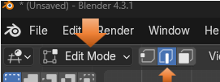

Now alt-click to select the first edge, and the shift -alt select to grab the second edge.

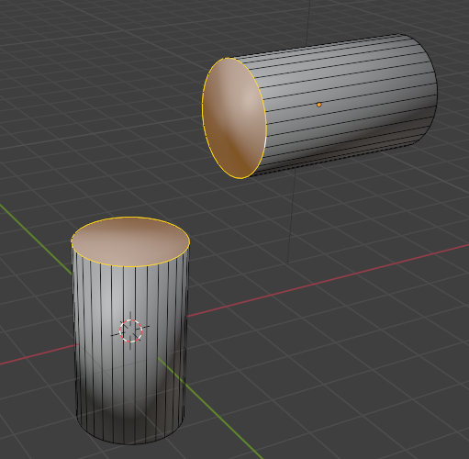

Now right click to be able to get to the menu where you can choose Bridge for your Loop Tool.

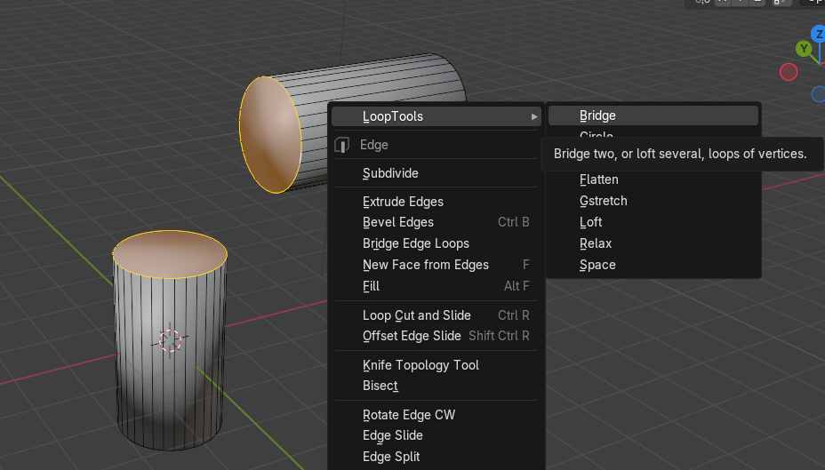

The Bridge will attach the two sections like this.

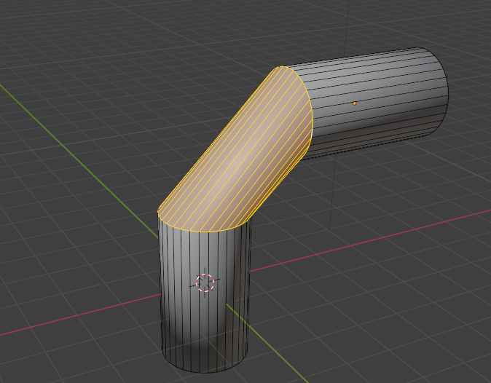

# The Options for the Bridge Tool

Go to the bottom left of the screen to access the options setting for this tool

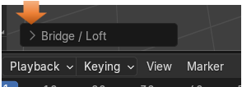

We want to increase the Segments in this dialog box to where the connection looks good.

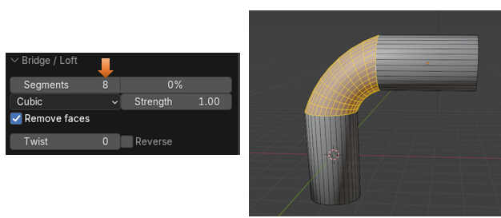

If you increase the Strength setting here, it will make this bend more pronounced.

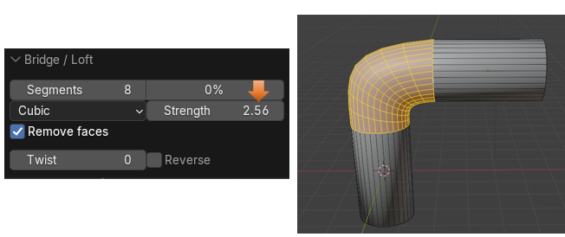

You can add a Twist to this, not that you would really want to in this case.

Or by hitting that Reverse checkbox this Twist can be reversed and go in the opposite direction.

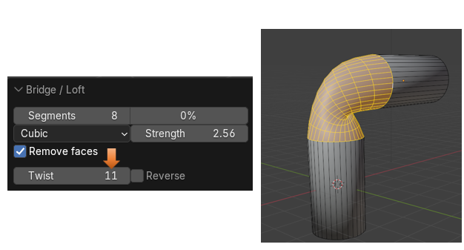

# Cutting a Hole

We can also use this tool to cut a hole in the mesh.

We can start with our original cube.

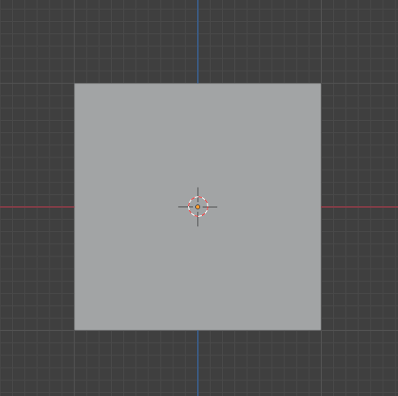

Go into Edit mode

Select the front and the back of the cube, while in Face Select mode.

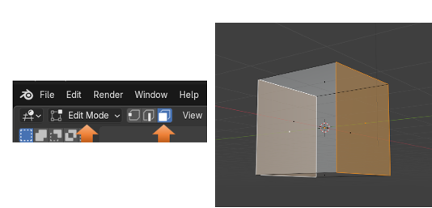

Now hit the I key to Inset and pull your mouse toward the left side of the screen.

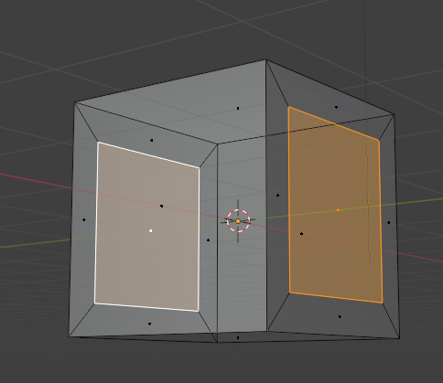

Now with both inset faces selected.

Warning, in order for this next step to work, you must have two faces selected, and not just one.

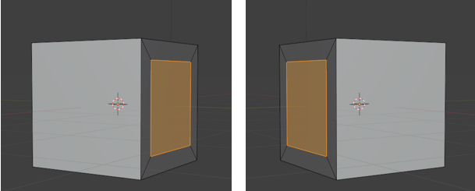

So, with both of the inserted faces selected, we want to right click, and select the option for Bridge from the Loop Tools again.

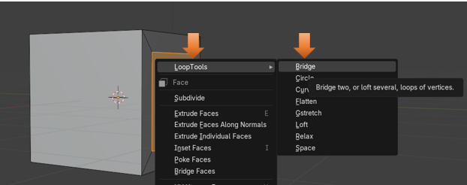

You will see that we now have created a hole in the mesh, going right on through.

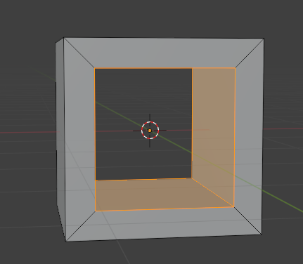

So, I guess that will be about it for the bridge tool, you will find many uses for this gadget as you make your own way through creating 3D Objects in Blender.